All Saints News
GREAT NEWS –
A Prayer for These Times
Keep us, good Lord,
under the shadow of your mercy
in this time of uncertainty and distress.
Sustain and support the anxious and fearful,
and lift up all who are brought low;
that we may rejoice in your comfort
knowing that nothing can separate us from your love
in Christ Jesus our Lord.
Amen.

.
June 2020
Edition 2
ALL SAINTS CHURCH WILL OPEN FOR PRIVATE PRAYER AS FROM SUNDAY 21ST JUNE BETWEEN 2 and 3 PM. SEE PAGE TWO FOR FULL DETAILS
VIRTUAL SERVICES
We are now running virtual services on a Sunday morning using Zoom as the delivery platform. The services begin at 10am and over 50 people are regularly joining us for relaxed on-line worship from our own church leaders.
If you are not already involved and would like to be do let us have your e-mail address and you will receive the invitation which carries the simple link to Zoom for the next service.
Do come and join us
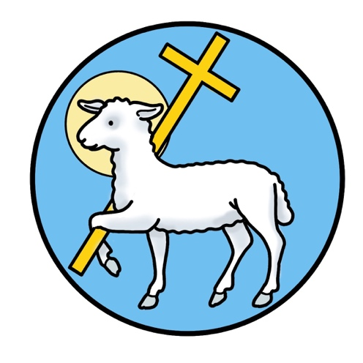
THOUGHT FOR THE MONTH:
Ordinary Time?
The church year is made up of seasons: it begins with Advent and ends with the “Christ the King”, which is the Sunday immediately before Advent. The season of Easter continues throughout the 50 days after Easter Day, taking us right up to Pentecost (Whit). That brings us to the long stretch between the end of Eastertide and the beginning of Advent, a period of what is called “Ordinary Time”. So, we are in Ordinary Time. It seems ironic, doesn’t it? Very little seems ordinary right now. But Ordinary Time is a season for us to focus on the life of Jesus, the events between the major festivals of Christmas, Easter and so on. And each of the church seasons has a colour associated with it, and for Ordinary Time it’s green – the colour of new life and hope.
As we focus on the life of Jesus we remember, for example, his miracles. At the wedding at Cana Jesus performed his first miracle: they had run out of wine, but Jesus turned water into wine. Jesus provided. St John’s gospel reports that Jesus used five loaves and two fish, brought to him by a small boy, to feed the five thousand. Again, Jesus provided. It is very hard for us to understand how these miracles were “performed”. It is harder still to wrestle with questions of why. Why did Jesus choose these occasions? Why did he heal some people but not others? But what the bible tells us is that God loves us and wants the best for us. God can and will provide. There are no earthly guarantees, but we can ask God to provide. We ask through prayer. And we remember that prayer is as much about understanding God’s will for us, as it is about asking for miracles.
Lord God, at this time which seems far from ordinary, please show us your will for us, help us to make wise decisions, and mercifully hear our cries for help. Amen

God can and will provide. There are no earthly guarantees, but we can ask God to provide. We ask through prayer. And we remember that prayer is as much about understanding God’s will for us, as it is about asking for miracles.
Lord God, at this time which seems far from ordinary, please show us your will for us, help us to make wise decisions, and mercifully hear our cries for help. Amen.
Julia
Faithful God,
When you call, may we respond;
When we falter, be our guide.
When you speak, may we hear;
When you ask, may we answer;
When we hesitate, be our resolve.
When you show, may we see;
When we disregard, be our conscience.
When you lead, may we follow;
When we stray, be our shepherd.
When you send may we go;
When we fear, be our courage.
When you challenge, may we listen;
When we fail, be our rock.
When you give, may we receive;
And may we love, as you first loved us. Amen.

Edited by Denis Pinnegar – denispinnegar@aol.com – 01325 720835
News sheet edited by Denis Pinnegar denispinnegar@aol.com - 01325729835
CHURCH REOPENS FOR PRIVATE PRAYER
After a thorough risk assessment, and in accordance with all Government guidance, we are pleased to announce that All Saints Church, Hurworth-on-Tees, will reopen for private prayer from Sunday June 21st.
To begin with, and until further notice, church will be open from 2pm – 3pm every Sunday.
You are welcome to come in, provided you agree to the following COVID-19 requirements:
- You do not have symptoms of COVID-19 and you are not self-isolating
- You maintain a 2m distance between yourself and anyone else not in your household
- You use the hand sanitiser provided, as you enter church
- You sit alone, or with members of your household, and only in one of the marked seats or the designated wheelchair area

We are not permitted to engage in shared worship in church yet. We also cannot put out prayer books, because of the risk of contamination, although you are welcome to bring your own to use.
We are continuing to live-stream worship every Sunday at 10am via Zoom, and if you would like further information about this, please contact:

Julia Clarke, Churchwarden juliahclarke@aol.com or phone 01325 720662

